Appendix 6: Parkes Special Activation Precinct

Appendix 6: Parkes Special Activation Precinct

This Appendix contains special provisions for development on land within the Parkes Special Activation Precinct In response to the tightening commercial realities of development within the Precincts, RGDC has made the decision to defer application of an additional 2% s7.12 contribution within the Parkes Precinct until 1 January 2027. This decision is the result of engagement with industry and wider stakeholders, including Councils, to continue supporting a resilient environment to further promote economic development and the creation of jobs within the Precincts.

This Appendix is structured as follows:

* 6.1: Background
* 6.2: Role of Regional Growth NSW Development Corporation
* 6.3: Relationship of this Appendix to other parts of this Plan
* 6.5: Relationship of this Appendix to other Plans and Policies
* 6.5: Land to which this Appendix applies
* 6.6: Development to which this Appendix applies
* 6.7: Contribution rates
* 6.8: Use of contributions
* 6.9: Review of this Appendix
* 6.10: Strategic planning framework
* 6.11: Expected development
* 6.12: Infrastructure strategy
* 6.14: Justification for 3 per cent levy
* 6.14: Infrastructure schedule
* 6.15: Infrastructure location maps.

1. Background

NSW Special Activation Precincts are areas in regional NSW that bring together planning and investment to boost jobs. They are being delivered by the NSW Government as part of the $4.2 billion Snowy Hydro Legacy Fund and being led by Regional Growth NSW Development Corporation (RGDC).

The Parkes Special Activation Precinct (Precinct) is one of four Precincts being delivered in NSW. The other Precincts comprise Moree, Wagga Wagga, and Snowy Mountains. Key elements of each Precinct comprise:

* Government-led studies
* Fast-track planning, for example, exempt and complying development
* Infrastructure development
* Business concierge.

The Parkes Precinct is a 4,821-hectare (ha) site, located 3 kilometres west of the Parkes township. It builds on Council’s development of the Parkes National Logistics Hub to establish a new enterprise hub taking advantage of the existing east-west Sydney to Perth and Adelaide rail corridor and the construction of an inland rail from Melbourne to Brisbane.

The Parkes Precinct Master Plan came into effect on 12 June 2020. In March 2022 the Activation Precincts State Environmental Planning Policy (**SEPP**) was consolidated with four other SEPPs into the State Environmental Planning Policy (Precincts-Regional) 2021.

The Parkes Precinct will become an inland port, transferring export ready goods to every major city and freight centre in Australia. It will provide opportunities for new industries in agriculture, freight and logistics, manufacturing, energy and resource recovery and transport to co-locate.

The delivery of Parkes Precinct is anticipated to result in a significant positive impact on the future growth in population and employment opportunities in the Parkes local government area (**LGA**).

This population and employment growth resulting from the Parkes Precinct will create additional demand for new and upgraded local infrastructure, including traffic and transport improvements to accommodate additional traffic movements, particularly from heavy vehicles, active transport infrastructure for resident workers accessing the precinct for employment, and water cycle management infrastructure required to appropriately treat stormwater and manage flood risks.

The Parkes Precinct is now in the delivery phase, led by RGDC. RGDC led the preparation of this Appendix amendment, in collaboration with Council.

RGDC will have primary responsibility for delivering most of the infrastructure on behalf of Council. While the NSW Government has committed significant funding towards infrastructure delivery, available funding will not deliver all of the projected infrastructure needs.

The Parkes Shire Council Section 94A contribution plan was originally prepared in 2016 and commenced on 5 August 2016. When it was prepared, it did not allow for the expected development and associated infrastructure requirements resulting from the Parkes. This appendices amendment was prepared in 2023 and contains special provisions specifically for the Parkes Precinct. Its purpose is to enable contributions to be imposed on development in the Parkes Precinct to help fund the cost of infrastructure that will be needed to support development in the Precinct.

1. Role of Regional Growth NSW Development Corporation

RGDC is the lead NSW Government agency with responsibility for delivering the NSW Special Activation Precincts, including Parkes.

The NSW Government has introduced Special Activation Precincts as a new way of planning and delivering infrastructure projects in certain regional locations in NSW, to attract and grow businesses, stimulate the local economy and provide more local employment opportunities.

However, to enable these benefits to be fully unlocked, councils must establish an infrastructure contribution framework for the delivery of the infrastructure required by the relevant council, and engage a third party (i.e. RGDC) to deliver the infrastructure in an accelerated timeframe on the council’s behalf.

The delivery of the infrastructure within the Parkes Precinct is being partially funded by the NSW Government as part of the $4.2 billion Snowy Hydro Legacy Fund, but this funding is not sufficient to deliver all the infrastructure required. That gap will be funded by Council, through the contributions levied under this Appendix. .

The infrastructure works to be partly funded by Council through contributions levied under this Appendix comprise road-related works, rail crossings, drainage works, and utilities works. RDGC will be responsible for the delivery and transfer of these works to Council once complete. A portion of the contributions levied on development in the Parkes Precinct will also be used by Council to help fund the delivery of local infrastructure to be delivered by Council as set out in the LGA-wide works schedule in Appendix 1 of this plan. Contributions received by Council under this Appendix and put toward the delivery of local infrastructure represents the contribution amount Council would ordinarily receive calculated in accordance with section 3.3 of this plan.

RGDC led the preparation of this Appendix, in collaboration with Council.

1. Relationship of this Appendix to other parts of this Plan

Provisions in this Appendix prevail over all other parts of this plan, to the extent of any inconsistency.

Development that is subject to a s7.12 contribution under this Appendix will not be required to pay a further contribution under any other part of this plan.

However, nothing in this Appendix or plan precludes Council from entering into a Planning Agreement with a developer, under which the developer agrees to provide material public benefits that are in addition to, or in instead of, contributions under s 7.12 of the Act (refer to section 3.7.2 of this Plan).

1. Relationship of this Appendix to other Plans and Policies

Development on land to which this Appendix applies will not be levied contributions under the Parkes Shire Section 94 Contributions Plan 2016.

1. Land to which this Appendix applies

This Appendix applies to land within the Parkes Precinct as shown in Figure 1 overleaf.

Figure : Land to which this Appendix applies

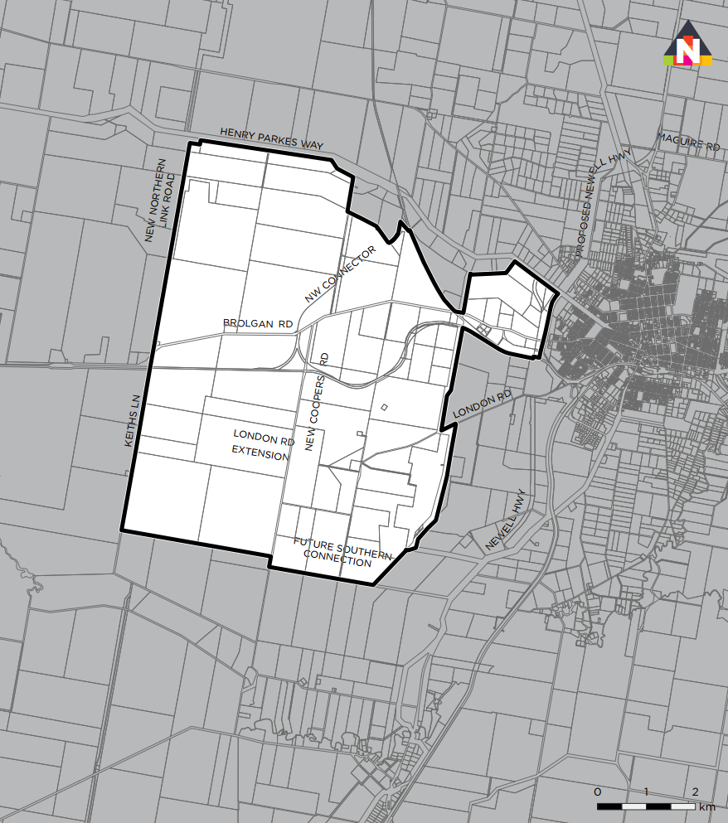

Source: Department of Planning and Environment (2020)

1. Development to which this Appendix applies

This Appendix applies to the same development as outlined in section 2.5. Similarly, this Appendix does not apply to development identified as being exempt from contributions in section 3.13 of this plan.

1. Contribution rates

Development on land to which this Appendix applies (Parkes Precinct land) is required to pay a section 7.12 levy calculated as a percentage of the development cost as outlined in the table below.

Table 6.: Contribution rates

|  |  |
| --- | --- |
| Development cost | Levy rate (% of development cost) |
| Up to and including $200,000 | Nil |
| More than $200,000 | 3% |

1. Use of contributions

Contributions paid and received under this Appendix will be applied as set out in the table below.

Table 6. Use of contributions under this Appendix

|  |  |  |
| --- | --- | --- |
| Development cost | Levy rate | Use / application |
| Up to and including $200,000 | Nil | - |
| More than $200,000 | 3% | Paid to Council.  1% retained by Council and applied to the infrastructure schedule in Appendix 1 of this Plan.  2% transferred to RGDC in consideration for the delivery by RGDC of the infrastructure schedule in section 6.13 of this Appendix on Council’s behalf. |

1. Review of this Appendix

This Appendix will be reviewed every five (5) years to ensure the plan’s works schedules respond to the evolving infrastructure needs of the Parkes Precinct and wider area.

Pursuant to section 215(5) of the EP&A Regulation, Council may make certain minor adjustments or amendments to the plan without prior public exhibition and adoption by Council. Minor adjustments could include minor typographical corrections.

It is expected that any review to this appendix would be led by RGDC and be undertaken in consultation and collaboration with Council.

1. Strategic planning framework

This Appendix has been prepared within a wider strategic planning framework for not only the Parkes Special Activation Precinct but the wider Mid-Lachlan region of NSW. A number of plans and strategies have been prepared by commonwealth, state and local governments to guide the future growth and direction of Parkes LGA over the next 20 years and beyond. A summary of the key plans and strategies of relevance to Parkes LGA’s economic and employment narrative and the development of the Parkes Special Activation Precinct are outlined below.

Parkes Special Activation Precinct Master Plan

In June 2020, the Department of Planning and Environment (**DPE**) finalised the Parkes Special Activation Precinct Master Plan. The master plan is an important part of the planning framework for the delivery of the Precinct and is a statutory planning document that supports the State Environmental Planning Policy (Precincts–Regional) 2021.

The master plan provides the Vision and Principles for the Parkes Special Activation Precinct, a Structure Plan and provisions to ensure that the vision is achieved. It also describes particular matters that should be addressed in more detail as part of the Delivery Plan, to be prepared in the next stages.

Leading up to the preparation of the master plan a detailed assessment of the investigation area was undertaken in 2019 and technical experts, ecologists, engineers, stakeholders and urban planners tested and refined scenarios and ideas to create the final master plan. Ongoing input and feedback from the community, landowners, businesses, and other key stakeholders also played a key role in the master planning process.

The master plan includes a set of guiding principles developed by DPE and Parkes Shire Council in consultation with State and Federal agencies for the Parkes Special Activation Precinct draft Master Plan. These Principles underpin the planning for the Parkes Special Activation Precinct and will be considered in the assessment of applications for Activation Precinct Certificates and the issuing of development consents.

The Master Plan sets out the aims and performance criteria for development within the Precinct, to ensure these principles are realised and provides industry, investors and stakeholders with the information and requirements to gain an Activation Precinct Certificate for development. These principles focus on the following key areas:

* Economic development
* Environment and sustainability
* Community
* Infrastructure
* Place and landscape

The master plan Structure Plan (Figure 6.2) for the Parkes Precinct identifies the anticipated land uses within the Precinct, potential location for the intermodal and rail terminal facility area and new and upgraded infrastructure required to support delivery of the Precinct.

Figure 6.: Parkes Special Activation Precinct Structure Plan

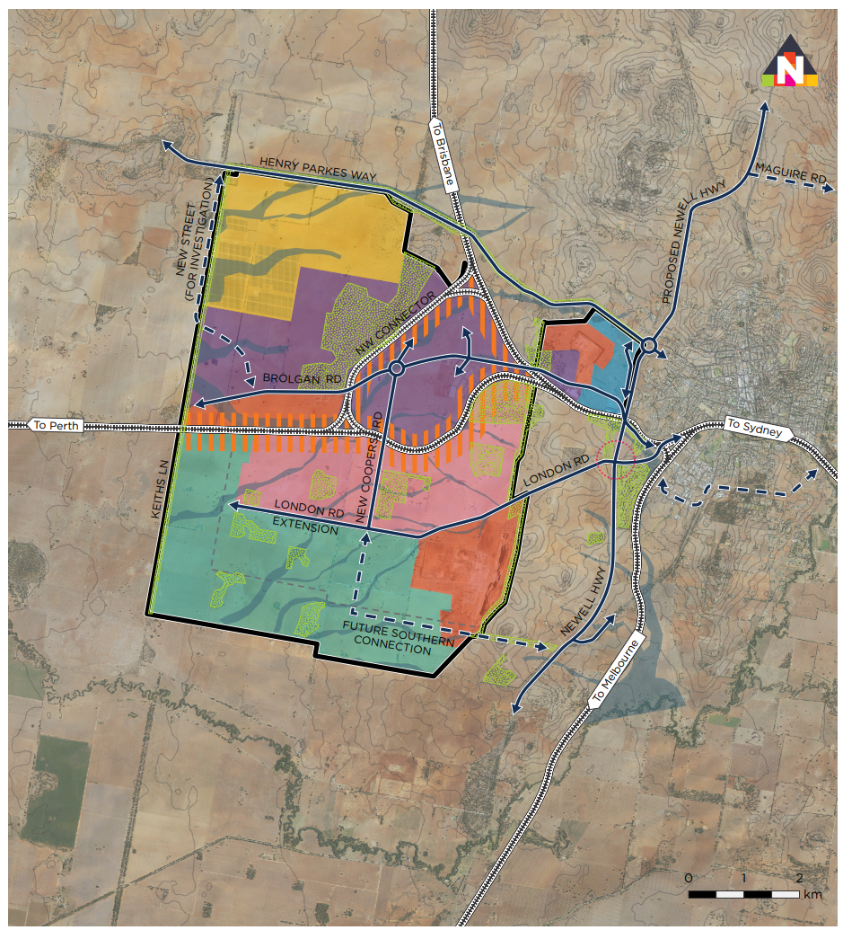

A 20-Year Economic Vision for Regional NSW (2018)

In 2018, the NSW Government released A 20-Year Economic Vision for Regional NSW which sets out a broad vision and economic strategy for all of regional NSW, except the metropolitan areas of Greater Sydney, Newcastle and Wollongong. The strategy document observed that regional NSW is Australia’s largest and most diverse regional economy. It is rich with natural resources, is home to a third of the state’s population and produces one-fifth of NSW’s gross state product.

The strategy categorises regional NSW into 37 functional economic regions (FERs). Forbes, Lachlan and Parkes LGAs, are located within the Mid-Lachlan FER and has been identified a ‘Inland’ due to being located beyond the Coastal and Metro Satellite areas, between and around Growth Centres. These areas are rural in character and have small, stable populations. Agribusiness and forestry are the main engine industries, employing more than 22 per cent of the overall workforce.

* The 20-year strategy has three core objectives:
* Amenity – to provide quality services and infrastructure in regional NSW
* Growth – to align policies to support growth in regional centres
* Potential – to identify and activate economic potential in regional NSW.

The priorities set out in the Vision statement complement other NSW initiatives already committed and recommended under other government strategies and long-term plans, such as the Future Transport Strategy 2056 and NSW State Infrastructure Strategy.

Mid-Lachlan: Regional Economic Development Strategy (2018)

The NSW Government with the Centre for Economic and Regional Development has also worked with Local Councils across Regional NSW to develop Regional Economic Development Strategies.

The Mid Lachlan Regional Economic Development Strategy 2018–2022 sets out a long-term economic vision and associated strategy for the Region’s economic development for the three LGAs of Forbes, Lachlan and Parkes Shire (the Region). The Strategy aims to leverage on the Region’s endowments, including:

* Optimise and grow agriculture by improving supply chain efficiency and quality, market access and communication
* Providing opportunities to expand current and future mining operations
* Improve water security constraints for the agriculture, mining, manufacturing and tourism industries
* Improve the availability of skilled labour for high value mining, construction, transport and manufacturing industries
* Improve access to markets for agriculture, mining and manufacturing by investing in intermodal network resilience and reliability
* Grow tourism in the Mid-Lachlan to diversify the economy.

Parkes Local Strategic Planning Statement (2020)

The Parkes Local Strategic Planning Statement set out the long-term strategic framework for planning and development in the Parkes local government area over the next 20-years.

It addresses issues of strategic significance to the Council, guiding development or introduction of new planning policies, strategies or actions related to land use and development.

Of relevance to this Appendix is Council’s objective to grow business investment with the Strategy acknowledging that the Precinct will facilitate the establishment of Parkes National Logistics Hub. New business opportunities are anticipated from Parkes being established as a centre of a national freight network including value added agricultural products; manufacturing; mining; circular economy and freight distribution.

The Strategy also acknowledges that the strategic importance of Parkes will increase over the next decade as the new Inland Rail project is development. Parkes Newell Highway Upgrade will also support employment and investment growth for the future. These connections integrate Parkes as a key location in inland New South Wales, directly linking the city to all major centres of eastern and central Australia.

This will allow Parkes to take advantage of economic trends and opportunities in the coming years. Parkes’ increasing interconnectedness to national and global networks will attract increased movements and freight volumes to and from the city.

1. Expected development

An economic and industry analysis report was prepared by SGS Economics and Planning in 2019 to support the development of the Parkes Special Activation Precinct Master Plan.

In its report, SGS:

* Developed three growth scenarios to test the take up and employment generation potential of the Parkes Precinct.
* Developed employment and land area projections for the Parkes Precinct over the long term.
* Provided a narrative for the sequencing and likely drivers for industry establishment in the precinct.
* Considered the implication on the Parkes LGA population as a result of potential future employment growth.

### Growth scenarios

As noted, SGS’ report developed three growth scenarios to test the take up and employment generation potential of the Parkes Precinct.

Low growth scenario

The low growth scenario is taken from NSW’s ten-year average annual employment growth rate (2006 to 2016). This is applied across the entire period of operation and represents a conservative growth projection that aligns with the state’s recent trends. It represents the ‘base case’, that is, the growth expected to occur without the Precinct intervention.

High growth scenario

The high growth scenario is based on analysis of comparable regional and urban precincts that have developed over a period of time as relatively specialised employment centres. While no precinct in Australia is directly comparable to what is proposed in Parkes, due to the specific locational and infrastructure characteristics of the Precinct as well as its scale, the use of multiple precincts to infer an average is appropriate mechanism to identify a growth rate.

The high growth scenario is derived from an analysis of nine separate precincts and the change in job numbers over five-year increments (at an annualised rate). What this demonstrates is that depending on the maturity of the precinct, the growth rate is rarely linear. Rather, precincts go through a phase of establishment, growth and then maturity. The average of these precinct growth rates has been used to identify the high growth rate by five-year increments to 15 years of operation. After that, a lower growth rate is applied to reflect reduced capacity.

Medium growth scenario (most likely)

The medium growth scenario has been taken as the median between the average of the high growth rates and the low growth rate. This is considered to represent the most likely outcome and is adopted for the purposes of this Appendix.

### Forecast growth summary

Specific growth figures are shown in the following table and charts.

Employment growth

Over the ten-year period from 2006 until 2016, employment in the Parkes LGA grew by 0.9% per annum. The Special Activation Precinct is likely to attract a number of different yet inter dependent industries and businesses. Over the 10-year period from 2021 until 2031, it is anticipated the Precinct could generate 913 additional jobs in the precinct under the medium growth scenario, an increase of 76 per cent.

Employment multipliers

Jobs growth in the Precinct is likely to create additional employment opportunities in the wider Parkes LGA. Applying the region’s employment multiplier to the direct jobs anticipated in the Precinct, it is anticipated that over the ten-year period from 2021 until 2031 the Precinct could generate 751 additional jobs in the Parkes LGA (excluding the Precinct), an increase of 76 per cent from 2021 employment levels.

Table 6. Forecast growth summary

|  |  |  |  |  |
| --- | --- | --- | --- | --- |
| Scenario | 2021 | 2031 | Change, 2021-2031 | |
| **Employment growth in Special Activation Precinct** | | | | |
| Low (base case) | 1,204 | 1,982 | 778 | 65% |
| Medium (likely) | 1,204 | 2,117 | **913** | **76%** |
| High | 1,204 | 2,301 | 1,097 | 91% |
| **Employment multipliers in Parkes Shire LGA** | | | | |
| Low (base case) | 991 | 1,631 | 640 | 65% |
| Medium (likely) | 991 | 1,742 | **751** | **76%** |
| High | 991 | 1,893 | 902 | 91% |

Source: SGS Economics & Planning- Economic and industry analysis final report (August 2019)

Figure 6.: Forecast employment – **Precinct** only

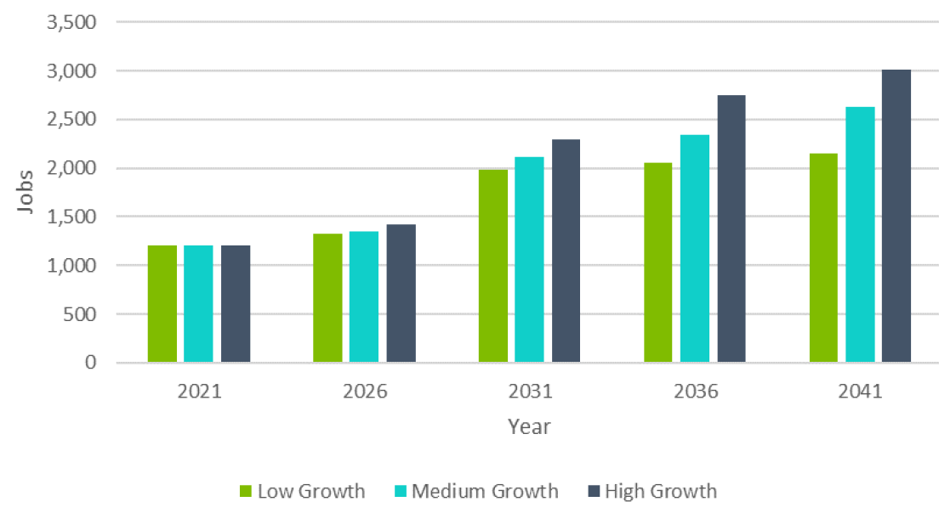Source: SGS Economics & Planning, Economic and industry analysis final report (August 2019)

Figure 6. Direct **Precinct** and indirect multiplier jobs (2041)

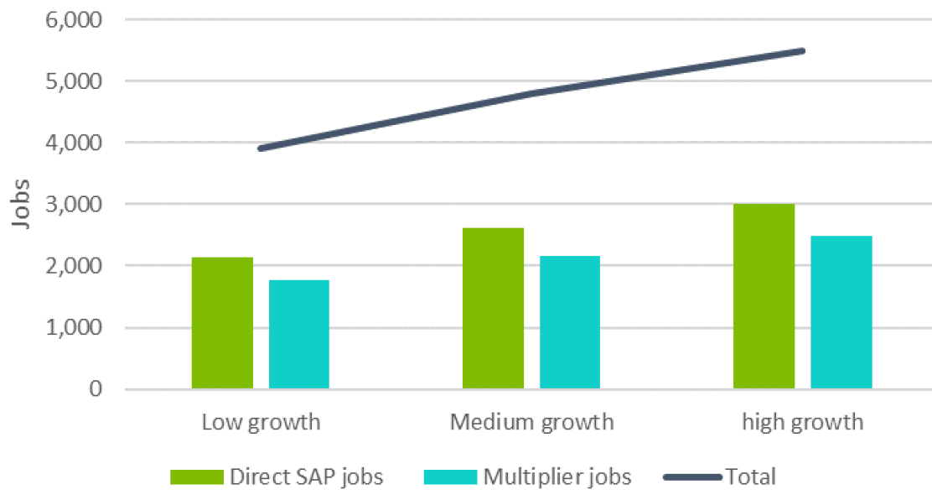

Source: SGS Economics & Planning- Economic and industry analysis final report (August 2019)

1. Infrastructure strategy

As outlined in the previous section, the Parkes Precinct is expected to generate significant employment growth both within the Precinct and Parkes Shire LGA.

Under the most likely scenario (that is, the ‘medium growth’ scenario), over the ten-year period from 2021 until 2031, it is anticipated the Precinct could generate 913 additional jobs, an increase of 76 per cent. In the wider LGA (excluding the Special Activation Precinct), it is anticipated the Precinct could generate 751 additional jobs, an increase of 76 per cent.

This employment growth will generate demand for a range of new and augmented infrastructure. Infrastructure to be delivered by RGDC in the Parkes Precinct on Council’s behalf, and funded through contributions collected by Council under this Appendix are shown in the works schedule in the following section.

As noted in section 6.8: of this Appendix, for development with a development cost over $200,000, this plan levies contributions on development calculated at three (3) per cent of the development cost. Contributions will be collected by Council. Council will retain one (1) percent and apply this to the works schedule in Appendix 1 of this plan. The remaining two (2) per cent will be transferred by Council to RGDC in consideration for the delivery by RGDC of the works in the works schedule in section 6.13 of this Appendix on Council’s behalf.

1. Justification for 3 per cent levy

The 3 per cent contribution levied on development in the Precinct over $200,000 under this Appendix is reasonable as the cost of infrastructure to be delivered in the Precinct and funded using contributions under this Appendix is substantially less than the cost of infrastructure to be funded using contributions under this Appendix.

The table below includes estimates of the following:

* Infrastructure demand reasonably attributed to development
* Expected contributions income under this Appendix
* Infrastructure costs expected to be funded from contributions under this Appendix.

As shown, 35 per cent of the infrastructure demand and cost in the Precinct from 2023 until 2031 can reasonably be attributed to development in the Precinct from 2023 until 2031. This equates to approximately $35.5 million of the $101.5 million in works to be delivered by RGDC in the Precinct.

Of this, it is estimated contributions will fund approximately $13.7 million of infrastructure to be delivered in the Precinct from 2023 until 2031. This equates to approximately 9 per cent of the cost of infrastructure to be delivered in the Precinct to support development in the Precinct from 2023 until 2031.

The 9 per cent of the cost of infrastructure to be delivered in the Precinct and funded using contributions under this Appendix is significantly less than the 35 per cent of the cost of the infrastructure that can reasonably be attributed to development in the Precinct from 2023 until 2031. The contributions that apply to development in the Precinct under this Appendix are therefore reasonable. The balance of the cost of the infrastructure will be funded using other funding sources, such as State Budget funding.

Table 6.: Infrastructure demand, costs, income and funding

|  |  |  |  |
| --- | --- | --- | --- |
| Item / description | | Formula | Value* |
| **Infrastructure demand and cost reasonably attributed to development** | | | |
| 1 | Precinct worker population, 2021 | A | 1,204 workers |
| 2 | Expected Precinct worker population, 2031 | B | 2,117 workers |
| 3 | Expected changed in worker population, 2021-2031 | C = B – A | 913 workers |
| 4 | Expected average annual change in worker population, 2021-2031 | D = C ÷ (2031 - 2021) | 91 workers |
| 5 | Expected worker population, 2023 | E = A + (2 ´ D) | 1,387 workers |
| 6 | Expected change in worker population, 2023-2031 | F = B – E | 730 workers |
| 7 | New workers as a % of 2031 worker population (Precinct infrastructure demand reasonably attributed to Precinct development) | G = F ÷ B | 35% |
| 8 | Precinct infrastructure cost to support new development | H | $101.5m |
| 9 | Precinct infrastructure cost reasonably attributed to Precinct development, 2023-2031 | I = G ´ H | $35.5m |
| **Expected contributions income** | | | |
| 10 | Assumed floor space per worker | J | 250m2/worker |
| 11 | Assumed development cost (derived from Rawlinson’s construction cost handbook) | K | $2,500/m2 |
| 12 | Contribution rate under this Appendix | L | 3% |
| 13 | Expected contributions income, 2023-2031 | M = F ´ J ´ K ´ L | $13.7m |
| **Infrastructure costs expected to be funded from contributions** | | | |
| 14 | 1% of 3% contribution to be retained by Council and applied to LGA-wide works schedule | N = 1/3 ´ M | $4.6m |
| 15 | 2% of 3% contribution to be transferred to RGDC to help fund works to be delivered by RGDC identified in s6.14 of this Appendix | O = 2/3 ´ M | $9.1m |
| 16 | Proportion of RGDC Precinct works cost to be funded using contributions under this Appendix | P = O ÷ H | 9% |

1. Infrastructure schedule

An infrastructure schedule is shown in the table below.

For each works item, it includes a description, estimated cost, and expected delivery timeframe. In summary, it contains a total of five (5) works with a total estimated cost of $101.5 million. Works comprise road-related works, drainage works, utilities works and two new rail crossings. All works items are expected to be completed in 2024. The schedule also includes an item associated to the administration costs related to this Appendix.

Table 6.: Infrastructure Schedule

|  |  |  |  |  |
| --- | --- | --- | --- | --- |
| Item | Description 1 | Description 2 | Estimated cost | Expected delivery |
| 1 | Brolgan Road - Stage 1 | Civil works associated with delivery of new roadway | $46.5M | 2024 |
| 2 | Brolgan Road - Stage 1 | Provision of landscaping and street lighting | $6M | 2024 |
| 3 | Brolgan Road - Stage 1 | Stormwater management and drainage | $4M | 2024 |
| 4 | Brolgan Road - Stage 1 | Lead in and subdivision electrical works | $5M | 2024 |
| 5 | Rail crossings | Provision of two grade separated rail crossings over Brolgan Road | $40M | 2024 |
|  |  |  | **$101.5M** |  |

1. Infrastructure location maps

The works map below shows the location of the works in the works schedule in the previous section of this Appendix.

Figure 6.: Parkes Special Activation Precinct works map

